Evaluation: ET-OvR
Accuracy: 0.9152970922882427
Precision: 0.9257335175494437
Recall: 0.9152970922882427
F1 Score: 0.9164897561301698
Jaccard Index: 0.8480918353555404
Matthews CorrCoef: 0.8939938415094335
Cohen’s Kappa: 0.8914391881649726
Specificity: 0.9876940338668209
AUC: 0.9972991060758163
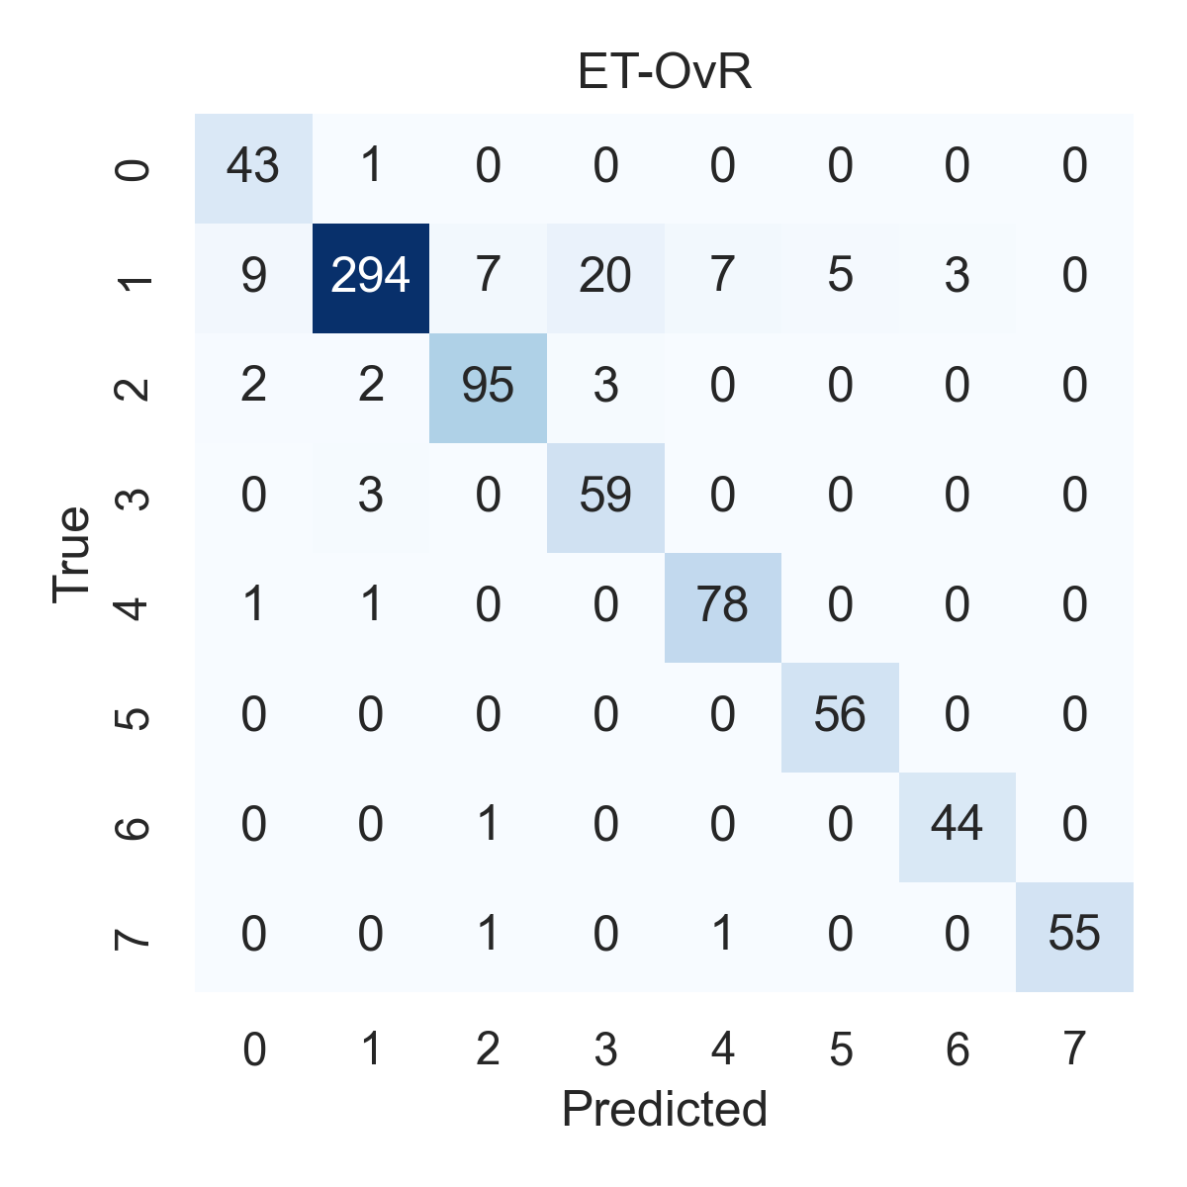

Combined ROC Curves
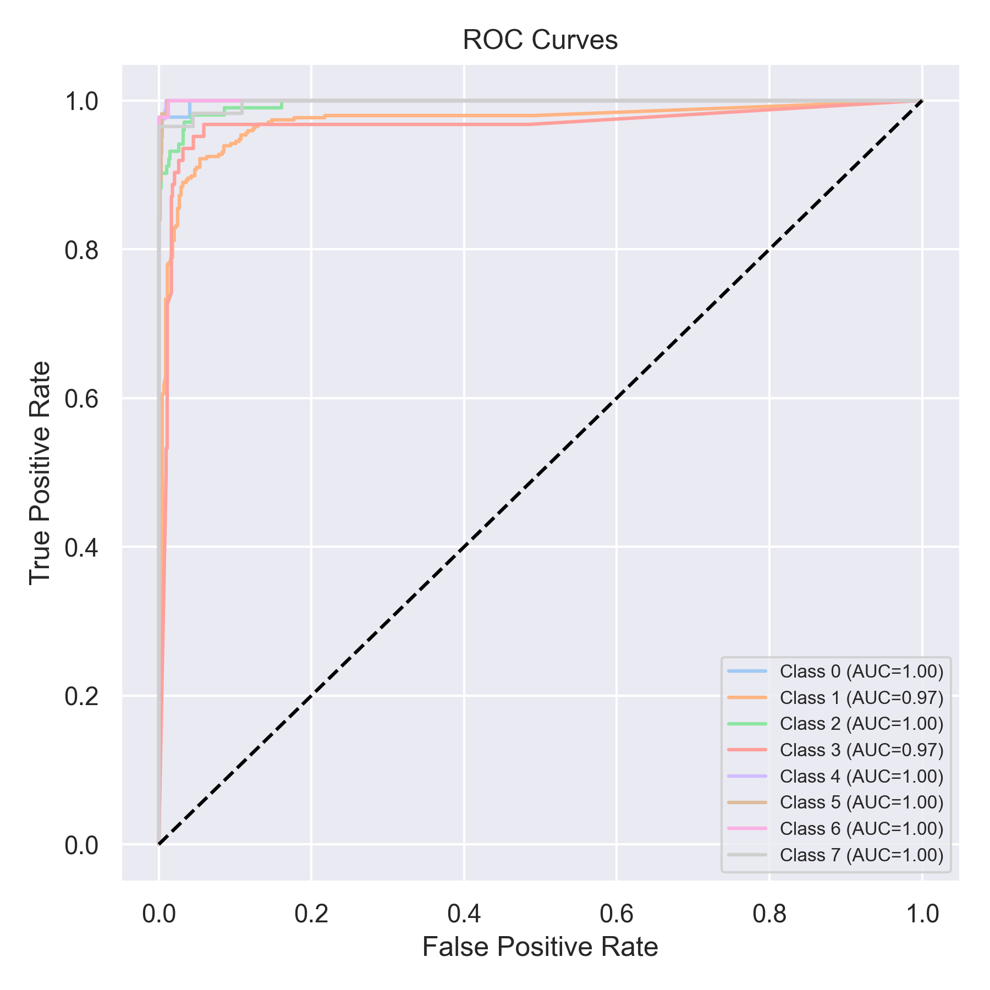

Evaluation: RF-OvR
Accuracy: 0.8912768647281921
Precision: 0.9064806193108488
Recall: 0.8912768647281921
F1 Score: 0.8930912881035579
Jaccard Index: 0.8105027834318352
Matthews CorrCoef: 0.8654703030164885
Cohen’s Kappa: 0.8616044090630741
Specificity: 0.9842188153079978
AUC: 0.9961757254170849
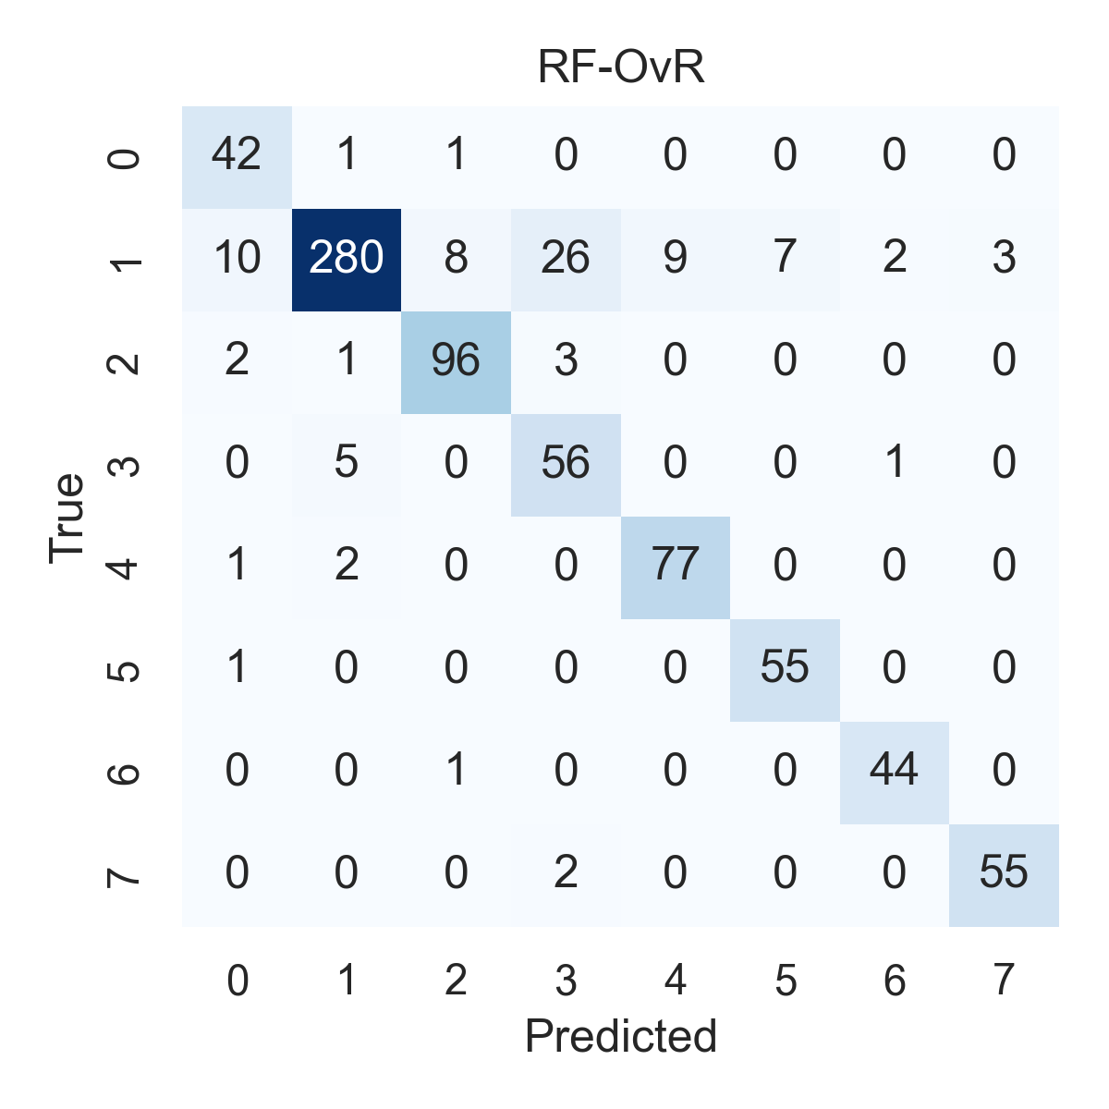

Combined ROC Curves
